NAME : MD KAJAL AGE : 24 YRS/ M
DATE: 31 January 2026 Refd. By DR.: DR. A K SINGH MBBS, UCMS, MS(G. SURGERY), FIAGES, FMAS, USMLE(USA), DNB(I), FICS, EISE, ECGMG(USA), MCh(NEUROSURGERY)
==============================================================================
This Scan has been Proudly done on Brand New, Most Advanced 3 Tesla MRI

PLAIN M.R.I. STUDY OF BRAIN

Images are acquired using T1, T2 & FLAIR axial, T1 Sagittal and T2 Coronal section

Findings
- Cerebral Hemispheres
  - Normal MR morphology.
  - Normal signal intensity.
  - Preserved gray-white matter differentiation.
- Basal Nuclei, Thalami, Corpus Callosum
  - Normal signal intensity pattern.
- Midline Structures
  - Septum pellucidum and falx cerebri in midline.
  - No mass effect or midline shift.
- Ventricular System & CSF Spaces
  - Bilateral lateral and third ventricles: normal.
  - Supratentorial sulcal and cisternal spaces: normal.
  - Fourth ventricle: normal size, midline position.
- Brainstem & Cerebellum
  - Normal morphology, signal intensity, and outline.
- Parenchyma
  - No focal or diffuse area of altered signal intensity.
  - No intra- or extra-axial space-occupying lesion.
- Dural Venous Sinuses
  - Normal outline and flow void.
- Sella & Parasellar Region
  - Sella, suprasellar, and parasellar structures: normal.
- Internal Acoustic Meatus & CP Angle
  - Bilateral regions: normal.

Impression
- Cavum septum pellucidum and cavum vergae noted.
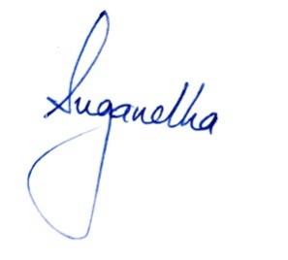
- Otherwise normal MRI brain study with no evidence of mass lesion, midline shift, abnormal signal intensity, or vascular abnormality.
Suggested : Clinico-pathological correlation/ Follow Up Study

